Flight Test Date: 2/25/2026
Simulink Model: ground_test_EMF (same as HoverTest_OLHeave)
Set up script:
%% EMF controller
% --------------
%Initalize Controller
% --------------
modelpath = 'JohnnyRMACLinearModels.mat';
trimSpeed = 0; % m/s
[EMF, aircraftIC] = setupEMF(modelpath, trimSpeed);

% --------------
% Load Hover Linear Model
% States = [x y z phi theta psi u v w p q r]
% Outputs = [phi theta psi u v w p q r Omegas udot vdot wdot pdot qdot rdot]
% Inputs = [dcol dlat dlon dped]
% --------------
tmp = load(modelpath);
HoverModel.A = tmp.As(:,:,1);
HoverModel.A(12,8) = 0; % Zero out Nv - likely due to wonky drag modeling but need to check
HoverModel.B = tmp.Bs(:,:,1); % Includes pseudo inverse
HoverModel.C = [tmp.Cs(4:16,:,1); tmp.As(7:12,:,1)]; % Add accelerations to outpus
HoverModel.D = [tmp.Ds(4:16,:,1); tmp.Bs(7:12,:,1)];

% --------------
% Initalize Conditions
% --------------
InitCond.lat_rad = 0.6229;
InitCond.lon_rad = -1.8491;
InitCond.ze_m = -100; %Inital Altitude
InitCond.phi_rad = interp1(EMF.VTAB, tmp.x_trim(4,:), trimSpeed);
InitCond.theta_rad = interp1(EMF.VTAB, tmp.x_trim(5,:), trimSpeed);
InitCond.psi_rad = interp1(EMF.VTAB, tmp.x_trim(5,:), trimSpeed);
InitCond.u_mps = interp1(EMF.VTAB, tmp.x_trim(6,:), trimSpeed);
InitCond.v_mps = interp1(EMF.VTAB, tmp.x_trim(7,:), trimSpeed);
InitCond.w_mps = interp1(EMF.VTAB, tmp.x_trim(8,:), trimSpeed);
InitCond.Omega1_rps = interp1(EMF.VTAB, tmp.u_trim(1,:), trimSpeed);
InitCond.Omega2_rps = interp1(EMF.VTAB, tmp.u_trim(2,:), trimSpeed);
InitCond.Omega3_rps = interp1(EMF.VTAB, tmp.u_trim(3,:), trimSpeed);
InitCond.Omega4_rps = interp1(EMF.VTAB, tmp.u_trim(4,:), trimSpeed);
InitCond.IdleOmega_rps = 1750*pi/30;

% --------------
% Initailize for PWM signal
% --------------
Kv = 1750; % Motor Constant, RPM/V
MaxOm_rps = Kv*25*pi/30*0.81;
MinOm_rps = 0;
MaxPWM_ms = 2000;
MinPWM_ms = 1098; % This is increased to the minimum PWM when armed

% --------------
% Initailize for Tracking Response (integral anti-windup)
% --------------
Enable_TR = 1;
Ktr_Col = 0.3;
Ktr_Lat = 3;
Ktr_Lon = 1;
Ktr_Ped = 1;

% --------------
% ACAH Gains - Updated to match PID rate feedback gains as of 1/14/26
% --------------
MixerGain(1) = mean(abs(HoverModel.D(10:13,1)));
MixerGain(2) = mean(abs(HoverModel.D(10:13,2)));
MixerGain(3) = mean(abs(HoverModel.D(10:13,3)));
MixerGain(4) = mean(abs(HoverModel.D(10:13,4)));
EMF.ACAH.RollP = 15*MaxOm_rps/1000/MixerGain(2);
EMF.ACAH.RollI = EMF.ACAH.RollP*0.1;
EMF.ACAH.RollD = 30*MaxOm_rps/1000/MixerGain(2);
EMF.ACAH.PitchP = 15*MaxOm_rps/1000/MixerGain(3);
EMF.ACAH.PitchI = EMF.ACAH.PitchP*0.1;
EMF.ACAH.PitchD = 30*MaxOm_rps/1000/MixerGain(3);
EMF.ACAH.YawP = 30*MaxOm_rps/1000/MixerGain(4);
EMF.ACAH.YawI = 15*MaxOm_rps/1000/MixerGain(4);

Test Matrix:
Task No. | Task Description
0 | Initial test of the controller  - Motor disarmed, rotating the drone by hand in pitch, roll, and yaw (positive rotation first followed by a negative rotation) – [50 100]s  - Control stick doublet input in pitch, roll, and yaw axis while throttle < 40 % - [100 150]s  - Attempt to take off with a pitch doublet command – [150 200]s
1 | Multiple attempts to take off but the drone continued to tilt to one side. Large stick inputs are required to center the attitude of the drone.
2 | Hand holding the drone while the feedback is on to test the compensation from the controller – [120 160]s
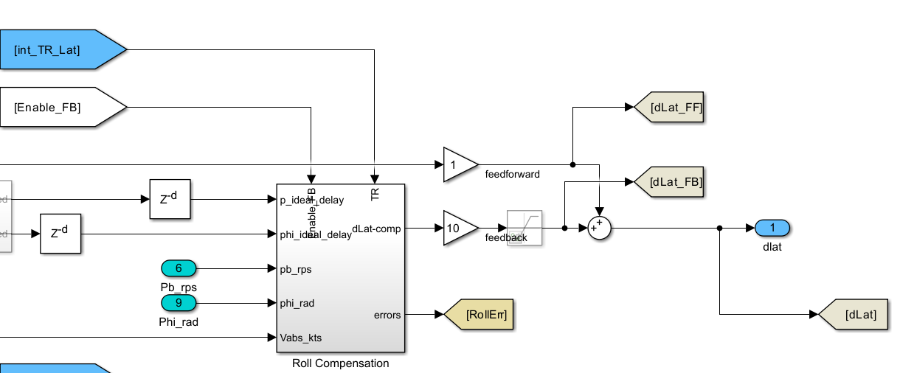
A gain of 10 is placed to increase the control input in roll

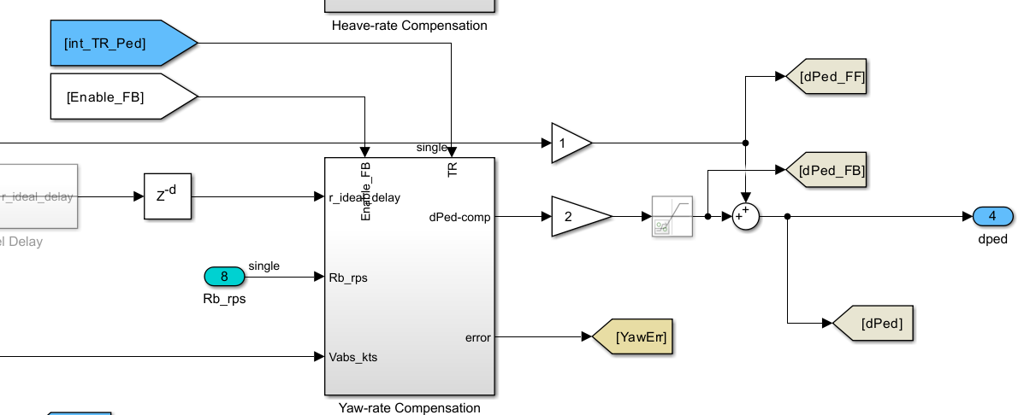
A gain of 2 is placed to increase the control input in yaw

Flight Test Date: 2/25/2026
Simulink Model: ground_test_EMF
Test Matrix:
Task No. | Task Description
2 | Initial test of the controller  - Motor disarmed. Drone is resting on solid ground– [115 150]s  - Throttle at ~40 % - [160 185]s
3 | Multiple attempts to take off but the drone continued to tilt to one side. Large stick inputs are required to center the attitude of the drone.
4 | Hand holding the drone while the feedback is on to test the compensation from the controller  - The drone is resting on level surface, hand tilting the drone in pitch, roll, and yaw axis – [250 293]s  - Thrust raised to 50 % and holding it in the air, rotating it in pitch, roll, and yaw axis to feel the compensation of the controller. Roll and yaw axis much weaker than pitch axis – [300 372]s

Test Script:
%% EMF controller
% --------------
%Initalize Controller
% --------------
modelpath = 'JohnnyRMACLinearModels.mat';
trimSpeed = 0; % m/s
[EMF, aircraftIC] = setupEMF(modelpath, trimSpeed);

% --------------
% Load Hover Linear Model
% States = [x y z phi theta psi u v w p q r]
% Outputs = [phi theta psi u v w p q r Omegas udot vdot wdot pdot qdot rdot]
% Inputs = [dcol dlat dlon dped]
% --------------
tmp = load(modelpath);
HoverModel.A = tmp.As(:,:,1);
HoverModel.A(12,8) = 0; % Zero out Nv - likely due to wonky drag modeling but need to check
HoverModel.B = tmp.Bs(:,:,1); % Includes pseudo inverse
HoverModel.C = [tmp.Cs(4:16,:,1); tmp.As(7:12,:,1)]; % Add accelerations to outpus
HoverModel.D = [tmp.Ds(4:16,:,1); tmp.Bs(7:12,:,1)];

% --------------
% Initalize Conditions
% --------------
InitCond.lat_rad = 0.6229;
InitCond.lon_rad = -1.8491;
InitCond.ze_m = -100; %Inital Altitude
InitCond.phi_rad = interp1(EMF.VTAB, tmp.x_trim(4,:), trimSpeed);
InitCond.theta_rad = interp1(EMF.VTAB, tmp.x_trim(5,:), trimSpeed);
InitCond.psi_rad = interp1(EMF.VTAB, tmp.x_trim(5,:), trimSpeed);
InitCond.u_mps = interp1(EMF.VTAB, tmp.x_trim(6,:), trimSpeed);
InitCond.v_mps = interp1(EMF.VTAB, tmp.x_trim(7,:), trimSpeed);
InitCond.w_mps = interp1(EMF.VTAB, tmp.x_trim(8,:), trimSpeed);
InitCond.Omega1_rps = interp1(EMF.VTAB, tmp.u_trim(1,:), trimSpeed);
InitCond.Omega2_rps = interp1(EMF.VTAB, tmp.u_trim(2,:), trimSpeed);
InitCond.Omega3_rps = interp1(EMF.VTAB, tmp.u_trim(3,:), trimSpeed);
InitCond.Omega4_rps = interp1(EMF.VTAB, tmp.u_trim(4,:), trimSpeed);
InitCond.IdleOmega_rps = 1750*pi/30;

% --------------
% Initailize for PWM signal
% --------------
Kv = 1750; % Motor Constant, RPM/V
MaxOm_rps = Kv*25*pi/30*0.81;
MinOm_rps = 0;
MaxPWM_ms = 2000;
MinPWM_ms = 1098; % This is increased to the minimum PWM when armed

% --------------
% Initailize for Tracking Response (integral anti-windup)
% --------------
Enable_TR = 1;
Ktr_Col = 0.3;
Ktr_Lat = 3;
Ktr_Lon = 0.5;
Ktr_Ped = 1;

% --------------
% ACAH Gains - Updated to match PID rate feedback gains as of 1/14/26
% --------------
MixerGain(1) = mean(abs(HoverModel.D(10:13,1)));
MixerGain(2) = mean(abs(HoverModel.D(10:13,2)));
MixerGain(3) = mean(abs(HoverModel.D(10:13,3)));
MixerGain(4) = mean(abs(HoverModel.D(10:13,4)));
EMF.ACAH.RollP = 15*MaxOm_rps/1000/MixerGain(2);
EMF.ACAH.RollI = EMF.ACAH.RollP*0.1;
EMF.ACAH.RollD = 30*MaxOm_rps/1000/MixerGain(2);
EMF.ACAH.PitchP = 15*MaxOm_rps/1000/MixerGain(3);
EMF.ACAH.PitchI = EMF.ACAH.PitchP*0.1;
EMF.ACAH.PitchD = 30*MaxOm_rps/1000/MixerGain(3);
EMF.ACAH.YawP = 30*MaxOm_rps/1000/MixerGain(4);
EMF.ACAH.YawI = 15*MaxOm_rps/1000/MixerGain(4);

% --------------
% RCHH Gains
% --------------
EMF.RCHH.P = 3;
EMF.RCHH.I = 1.5;

% Flags
EnableSpeedHold = 0;
EnableRCHH = 0;
EnableInputNoise = 0;

